**Know**

**“The Five**

**Protective**

**Factors!”**

The *National Alliance of Children’s Trust & Prevention Funds* developed the **Strengthening Families™ Protective Factors Framework**

into a curriculum called

**Bringing the Protective Factors Framework to Life in Your Work**

It helps identify and build upon the strengths, assets and needs of families for the well-being of children while reducing the risk of maltreatment

— and is applicable across the range of programs, service providers, organizations and audiences.

**Lakeshore CAP**

**2nd Floor Conference Room**

**702 State Street**

**Manitowoc, WI 54220**

**Phone: 920.682.3737**

* **Free**

***This training is being offered at no charge!***

* **April 17 (6:00-8:00)**

***— Introduction to the Five Protective Factors***

* **May 15 *(6:00-8:00)***

***— Children’s Social Emotional Competence***

* **June 19 *(6:00-9:00)***

***— Social Connections and Concrete Support in Times of Need***

* ***Dates and Times for Additional Trainings to be determined***



**Register by emailing**

[jribley@lakeshorecap.org](mailto:jribley@lakeshorecap.org)

**Location/Cost Time/Date/Sessions**



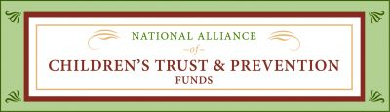

**Note the Date and Time for Each Session**