The *Wisconsin Child Abuse and Neglect Prevention Board* utilizes the **Strengthening Families™Protective Factors Framework** to guide its own work and the efforts it supports.

The **Protective Factors Framework** helps to identify and build upon the strengths, assets and needs of families as a means to simultaneously enhance the well-being of children while reducing the risk of child maltreatment. It is an approach and not a program and is designed to be incorporated in the everyday actions of those who work with families. Consequently, the **Protective Factors Framework** is applicable across the range of programs, service providers, organizations and audiences.

The Framework was developed by the *Center for the Study of Social Policy* utilizing findings from field observations, a thorough review of research, and input from prevention and early childhood experts.

Their efforts resulted in a strengths-based, evidence-informed framework composed of five protective factors. This effort is aimed at promoting the understanding and capacity for developing and enhancing five foundational protective factors.

***Know “The Five Protective Factors!”***

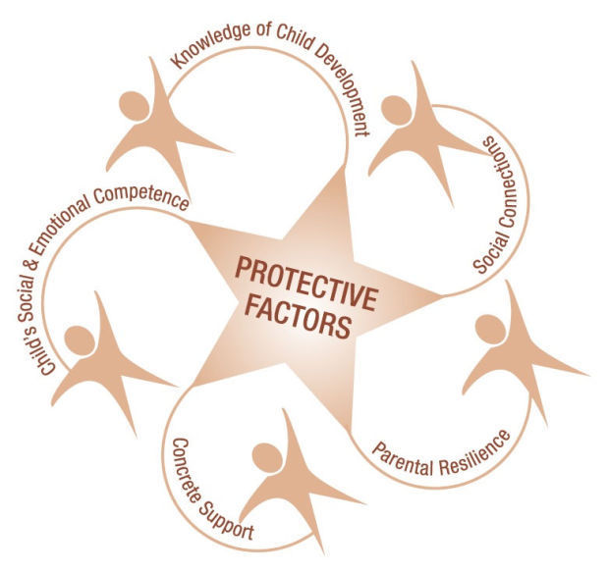

**1. Parent Resilience:** The ability to recover from difficult life experiences and often to be strengthened by and even transformed by those experiences

**2. Social Emotional Competence of Children:** Family and child interactions that help children develop the ability to communicate clearly, recognize and regulate their emotions, and establish and maintain relationships

**3. Knowledge of Parenting and Child Development:** Understanding child development and parenting strategies that support physical, cognitive, language and social emotional development

**4. Social Connections:** Positive relationships that provide emotional, informational, instrumental and spiritual support

**5. Concrete Support in Times of Need:** Access to concrete support and services that address a family’s needs and help minimize stress caused by challenges

**Strengthening Families™**

**Protective Factors Framework**

**COURSE TRAINING**

**Helping People; Changing Lives**

**Sheboygan County**

**2508 S 8th St**

**Sheboygan, WI 54235**

**920-694-0041**

**Bringing the Protective Factors Framework to Life**

**in Your Work**



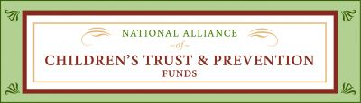

**April 20th & 27th 2018**

**at Manitowoc County Health Department**

**The Benefits to YOU!**

**The Training**

**The Center for the Study of Social Policy research has shown that protective factors:**

* ***Benefit all families***
* ***Reduce the risk of child maltreatment***
* ***Strengthen families***
* ***Promote optimal child and youth development***

Participants will leave with:

* *A better understanding of how to utilize the* ***Protective Factors Framework*** *in their work to strengthen families*
* *An understanding of how culture impacts perspectives and how to best work with families*
* *A renewed appreciation for the value of parents as partners in their work*

**Time/Dates/Sessions**

**10:00 AM – 4:30 PM**

**April 20th Sessions**

* ***Introduction to the Five Protective Factors***
* ***Parental Resilience***
* ***Knowledge of Parenting and Child Development***

**April 27th Sessions**

* ***Social Emotional Competence of Children***
* ***Social Connections***
* ***Concrete Supports in times of need***

**Location/Training/Cost**

**Manitowoc County Health Dept**

**1028 S 9th Street**

**Manitowoc, WI 54220**

**Phone: 920.682.3737**

* **$10 per session *— IF your employer is paying for you to attend***
* **Free *— IF you are a volunteer, student or not being paid for your time to attend***
* **Materials are provided**
* **Lots of hands-on activities!**
* **Lunch and snacks will be served**

**The Curriculum**



**Register by contacting**

**Colleen Homb at**

**920-686-8705**

In 2012, the *National Alliance of Children’s Trust & Prevention Funds* developed the **Strengthening Families™Protective Factors Framework** into a curriculum called **Bringing the Protective Factors Framework to Life in Your Work**. It is designed to assist professionals who work with families and children to promote the optimal development of all children while protecting vulnerable children from harm.

The training consists of **six 2-hour modules** that share ways to help practitioners, community members and parents better understand and address family needs utilizing a strengths-based lens.

**The curriculum . . .**

*. . . Is built on the premise that* ***every*** *family has strengths*

*. . . Provides a detailed explanation of the five protective factors*

*. . . Focuses on helping to make “small but significant changes” in practice and service provision, family life, parenting and child development*

2017